
Educational Performance Analysis


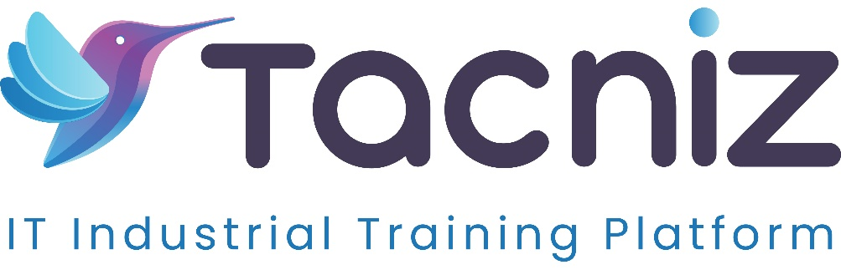

Problem Statement
Schools and educational institutions often struggle to analyze student performance data effectively. Factors like exam scores, attendance, and participation can provide valuable insights into a student's progress, but without proper analysis, identifying trends or at-risk students becomes challenging. A system that can analyze this data, identify patterns, and predict outcomes is necessary for improving educational strategies and ensuring better learning outcomes.

Type
  - Educational Data Analysis and Prediction Tool.

Industry Area
  - Education, Data Analytics, Learning Management Systems (LMS).

Software Expertise Required
  - Data Analytics: Use Python (pandas, NumPy) or R to analyze student data, including exam scores, attendance, and participation.
  - Machine Learning: Build models to predict student outcomes and identify at-risk students using scikit-learn or TensorFlow.
  - Data Visualization: Matplotlib, Seaborn, or Power BI to create charts and dashboards that showcase trends and patterns in student performance.
  - Backend Development: Python (Django/Flask) or Node.js to manage student data and run analytics models.
  - Database: PostgreSQL, MySQL, or MongoDB for storing student data and performance metrics.
  - NLP (Optional): Use Natural Language Processing (NLP) to analyze text-based feedback or participation in discussion forums.

Use Cases
  - Schools or educators can input student data (e.g., exam scores, attendance records, participation levels) into the system.
  - The tool analyzes this data to identify patterns, trends, and correlations between performance, attendance, and participation.
  - Predictive models highlight at-risk students based on past performance and other indicators.
  - Educators receive recommendations for interventions, such as tutoring, counseling, or additional resources, to help improve student outcomes.
  - Schools can generate performance reports for classes or individual students, helping them to tailor educational strategies.

Outcomes
  - A clearer understanding of the factors affecting student performance, including attendance and participation.
  - Early identification of at-risk students, enabling timely interventions to improve outcomes.
  - Data-driven recommendations for improving learning strategies, targeting areas where students struggle most.

Benefits
  - For Educators and Schools:
    - Improved ability to track and understand student performance over time.
    - Timely identification of students who need additional support, reducing the risk of academic failure.
    - Tailored educational strategies based on real data, leading to better learning outcomes and higher retention rates.
  - For Students:
    - Early intervention based on performance analysis, leading to improved academic success.
    - Personalized learning plans that address their specific needs and challenges.
  - For Administrators:
    - Enhanced reporting on school or classroom performance, helping to inform policy and educational programs.
    - Efficient allocation of resources based on where students need the most support.

Duration
  - Estimated 4-6 months

